Cantraybridge

Newsletter

June 2023

Welcome to your newsletter

After a chaotic time recruiting and retaining staff, we now have a great team working in the café. Please pop in on a Wednesday, Thursday or Friday between 11am and 3pm to sample some of our great food. Much of the food is sourced from our own market gardens.

The new IL Hub is now complete with a dedicated area for sleepover staff. This looks amazing and will give staff a lot more room when they are on a sleepover shift.

Work will begin in house three over the next 3-4 months after which we will be able to take in 2 more residents.

Staff Profile

Our staff profile is on our new Café Enabler, Cindy Milne



Family is everything for me and I am a very happy mum to Megan, Lewis and Jessica and a Nana to my grandchildren Oliver, Orla and Killian who are a total joy to be around, and I love to spend my spare time with them, going to the park or playing in the garden

I am delighted to be working here at Cantraybridge, in such a rewarding post, My background in hospitality was Manager at The Classroom Bistro in Nairn and Assistant Manager of Boath House to be able to share my knowledge and skills with the students has been fun. In my spare time I was also the Hospitality and Tea Hut Manager at Nairn County Football Club. I am still involved with Nairn County Football club, but as I have a little more time, I am Head of Youth Development working alongside a great team of volunteers.

You might also see me on the stage as I am part of the Little Theatre drama club in Nairn, and love to play some funny characters.( recently just playing Mrs T-Cup in adult panto)

Department Updates

Learning and Development – Norma Cameron

Animal Care
We have had a good lambing with 40 lambs from our 21 ewes. We have one pet lamb who has been named Morag, who is very popular with staff, students and visitors. We have purchased 5 replacement young sheep to join our main flock later on in the year when some of the older ewes will have to go to market. We have been looking after a local farmer’s cattle over the winter months and they left us in April. When not busy looking after the farm animals, the team have been busy with grass cutting and farm maintenance.

We are continuing to develop the small animal department with projects like new a new pathway which provides safer access around the department. The exotic animal room will continue to be enhanced along with a large project in the tropical house being built to breed Neo tropical species of butterfly. We are considering adding a chameleon or Chinese water dragon to the department. The students have really been enjoying looking after interesting species of animals and it is great to see their confidence growing.

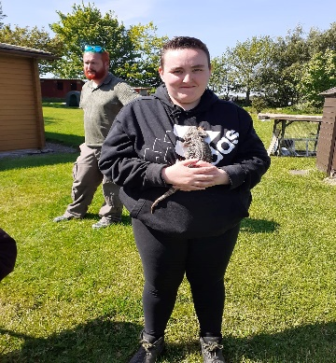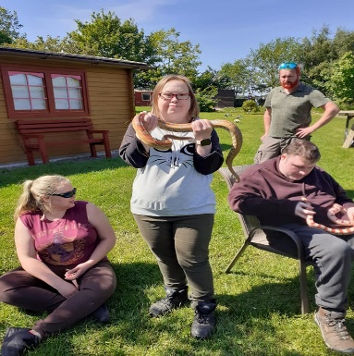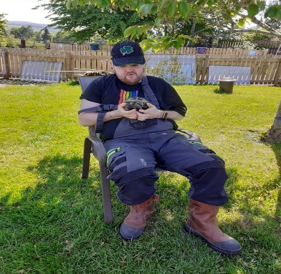

Horticulture
This is the busiest time of year for the department with our students working hard to plant up our tunnels and outside beds. The department have also been bringing on plants to sell in our plant shop which should reopen next month. We continue to provide vocational training in horticulture including the commercial experience of working in a market garden and plant nursery. As well as delivering the SVQ level 1 Horticulture award, we are now delivering the Royal Caledonian Horticultural Society’s Grow and Learn Award.

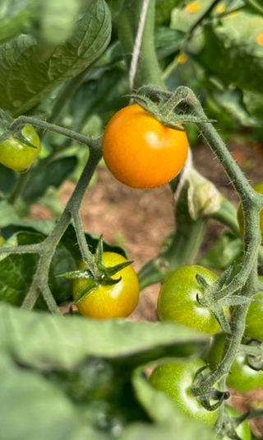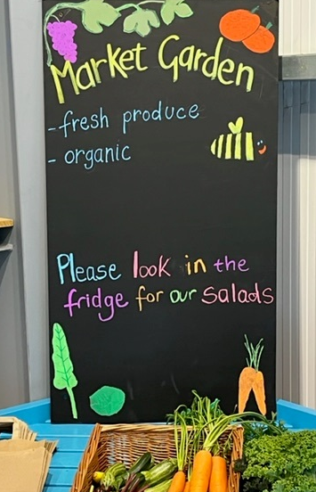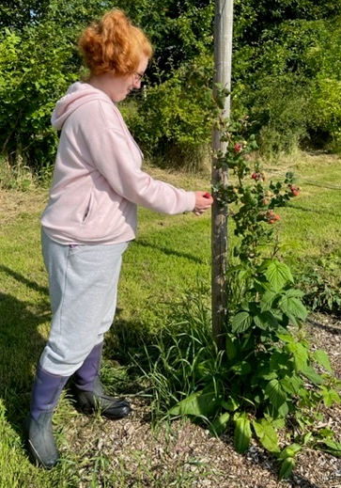
The department take a holistic approach in everything they do. An important aspect of this is environmental education including protecting and encouraging biodiversity, climate change and reducing plastic pollution. This year students have taken part in RSPB’s Big Garden Birdwatch and BBC’s Wild Weekender. We grow organically and peat free and regularly deliver the John Muir Award. We promote healthy eating and the importance of limiting food waste by encouraging our students to eat cook and preserve the fruit and vegetables they grow. One of our 1:1 supported students has been using our potting shed kitchens to make pizza and jams.

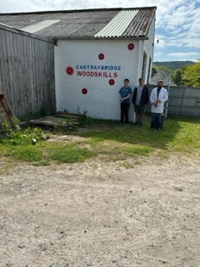

The wood skills team have been taking advantage of the good weather to brighten up the department with a fresh coat of paint on the external walls. Old, decaying signs and wall art has been removed and a new sign has been sprayed. The wooden front is also getting painted and some new (old) doors are being fitted to tidy up but also bring back the functionality they should have.
Recently the wood skills team made a large raised bed for the horticulture department and a frame to go over to keep out the beasties. The team put their skills into great use and have been repairing/ damage limitation around the site for other departments eg securing the end of the poly tunnel which has been flapping around in the wind and making new doors for the maintenance department. We will shortly be assisting with the cladding and structure aspects of the butterfly house within the animal care team.

Maintenance

The skills of the maintenance department team are put to use on a daily basis. The team have been helping out with small electrical, plumbing and wood work tasks. A large part of the day can be spent helping out with maintenance tasks in the independent living accommodation eg putting together furniture, unblocking toilets and showers, fixing washing machines. We also have a social aspect to the department and will sometimes finish the week off using our karaoke machine. We will soon be helping out with some of the painting in House 3.

Operational Matters – Miriam Hendry

Recruitment
We are currently looking to recruit staff for our Independent Living Area and for Community Support. An incentive scheme is in operation so if you refer someone to us and they are successful in obtaining a position at Cantraybridge you can be awarded up to £100. If you have anyone in mind please let one of the managers know.

We held a recruitment day in Eastgate Shopping Centre on 5th May and are planning a further recruitment day at Inverness Careers Fayre in October.

Lots of changes have been made to our internal record keeping and Cantraybridge is now using the latest technology from Microsoft in this respect.

Independent Living – Karen Peebles
There has been a great deal of excitement about the refurbished Amenity Hall. The residents have already made decisions about resources: a snooker or pool table and a darts board. DC GAZE, the residents committee, have given feedback and would also like a coffee/ tea area, which we hope that with support from our team they can start up and take forward ownership for this.
We have been able to facilitate trips to concerts in Glasgow where the students were very independent, and feedback was that they had a ball. A holiday to Ayr gave a group their first holiday away from family.
We have more plans ahead for holidays, concerts, new activities, and experiences with the emphasis on opportunities to explore and develop.
Transitions in - are under way for a new person to move into the Square into house 2, so again we continue to be at full capacity.
Transitions – out, working hard with a small group of students to support them into housing in the community.. One young person has been allocated a new property in Nairn. Her new home should be ready late October. We are working in partnership with other agencies to support another young man to move to his own tenancy in Inverness.

Business and Finance– Ian Larg

Finance

Community Support referrals have been strong over the last couple of months with a significant increase from the first part of the year. We have taken on 4 new clients with some others still in the discussion phase. For larger packages, we are trying to outsource the support to other providers either singly or by consortium. This is being tried due to the difficulty of recruiting support staff.

Our first audit with A9 as auditors will commence onsite during the week commencing 5th June. They have done some preliminary work and also visited the site to get a fuller understanding of the work we do.

So, a lot of exciting things happening at Cantraybridge and great to be able to see students and staff alike out and about and clearly enjoying the lovely summer weather

